Nitrogen generation for vessels with DF propulsion
Double your lead
The use of dual-fuel (DF) propulsion systems offers modern vessel operators decisive advantages when it comes to achieving a progressive and leading market position. As a future-oriented owner, why not double your lead by installing the most energy-efficient and cost-effective nitrogen system available on board your ship? With its SK/ASK/ASD-series rotary screw marine compressors, Kaeser can provide the perfect solution.
Both the specific energy consumption and the overall life-cycle expenses of shipboard nitrogen generators for DF systems are predominantly determined by their feed-air compressor. Parameters such as discharge pressure and discharge temperature, as well as the compressed air quality supplied by the feed-air compressor, have a decisive impact upon the design of a nitrogen generator. For example, a feed-air compressor with the highest discharge pressure and the lowest discharge temperature results in a more compact and energy-efficient design for the nitrogen membrane generator, even when operating in the harsh conditions of a machine room.
Since every cubic metre of nitrogen produced requires between two and three cubic metres of feed air, the impact of the feed-air compressor on the specific energy consumption of a nitrogen generator for a DF system becomes evident immediately. Moreover, the quality of the compressed air produced has a direct impact upon the maintenance expenses for your nitrogen generator – poor air quality will jeopardise the availability of your nitrogen generator, and perhaps even damage it irreparably.
In summary, a feed-air compressor with the highest discharge pressure, the lowest discharge temperature, the best specific energy efficiency, the highest air quality and preferably the lowest maintenance expenses would be the perfect solution. Perhaps this sounds like the realm of fantasy, but fortunately feed-air compressors such as this do actually exist.
As the leading worldwide supplier of feed-air compressors for shipboard nitrogen generation systems, Kaeser Kompressoren offers three product lines of marine rotary screw compressors specially designed for vessels with DF propulsion.

SK series
Kaeser’s air-cooled SK rotary screw marine compressors with flow rates between 1.3 and 2.5 m³/min and stable discharge pressures from 8 to 16 bar(g) represent the smallest range of feed-air compressors. Their cooling system features an innovative dual-flow fan, which not only ensures exceptional cooling performance, but also keeps sound emissions to an absolute minimum. Thanks to Kaeser’s unique Sigma rotary screw profile, SK marine compressors feature the lowest specific energy consumption of their class. Even these small compressors can be certified for essential duty operation by all major classification societies.
ASK series
Air-cooled ASK rotary screw marine compressors with flow rates between 1.85 and 4.0 m³/min and stable discharge pressures from 8 to 14 bar(g) are the next largest series of energy-efficient feed-air compressors from Kaeser. Due to their larger, low-speed airends with Sigma Profile rotors, which are designed and manufactured with exceptionally small tolerances, ASK marine feed-air compressors enable improvements of more than 15% when it comes to specific energy consumption. Furthermore, when combined with a three-stage, high-efficiency oil/water separator, these airends ensure the highest feed air quality at the inlet of your nitrogen generator.
ASD series
Unmatched values in terms of discharge pressure, discharge temperature, specific energy efficiency, air quality and maintenance expenses make ASD marine feed-air compressors from Kaeser the top of the range. Air-cooled, FW-cooled or even seawater-cooled, these direct-drive marine rotary screw compressors with flow rates between 3.0 – 5.4 m³/min and stable discharge pressures up to 14 bar(g) represent the maximum you could wish for from your feed-air compressor. Moreover, Kaeser’s innovative Electronic Thermal Management (ETM) system dynamically controls the oil temperature in order to keep it constant and at a safe distance from its condensation temperature. Lowest, stable compressed air discharge temperatures are ensured thanks to Kaeser’s ASD marine compressors.
All feed-air compressors from Kaeser are standard-equipped with the in-house Sigma Control system for fully automatic or remote operation of the compressor. Special software for various internal compressor control modes is available for maximum energy consumption savings. Of course, all possible motor starter options are additionally available for each of the three feed-air compressor series.
Double your lead by installing feed-air marine compressors from Kaeser as the shipboard nitrogen generator for the DF system aboard your vessel. And, since every little counts, they will even contribute to an improvement of the EEXI and CII for your DF vessels!
Please visit www.kaeser.com/marine for more specific information about our SK, ASK and ASD marine feed-air compressor series.

Approved for publication, copy appreciated

Images:

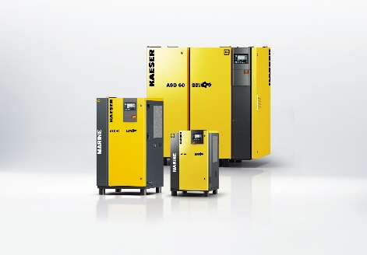

Kaeser provides the most effective solution for all requirements.
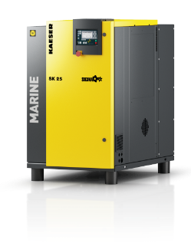
The SK is the smallest solution in the marine range, with flow rates between 1.3 and 2.5 m³/min and stable discharge pressures from 8 to 16 bar(g).

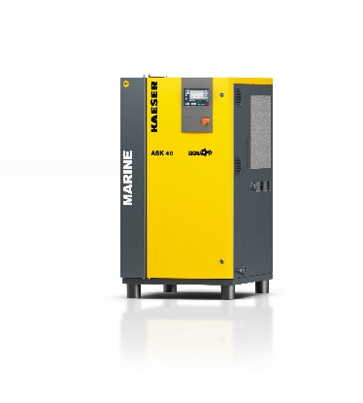
The ASK series, with flow rates between 1.85 and 4.0 m³/min and stable discharge pressures from 8 to 14 bar(g), represents the mid-range.

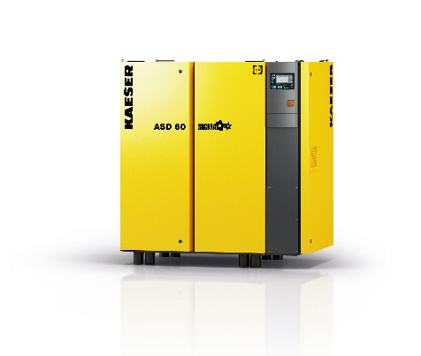

The ASD series, with flow rates between 3.0 – 5.4 m³/min and stable discharge pressures up to 14 bar(g), represents the maximum range.

