Kaeser Marine Service
Support is always there
When it comes to compressed air on board a vessel, a reliable supply is one of the most important factors. Kaeser Marine Service ensures help is always available in the event of an issue, as well as for regular service intervals – wherever in the world you may be.
Globally networked and coordinated centrally from Marine Head Office (MHO) in Coburg, Germany, qualified Kaeser service specialists are available if needed at the next port of call, as soon as the ship has berthed. Six specialised Marine Service Hubs (MSH) located in Houston, Coburg, Oslo, Busan, Shanghai and Singapore are also available to provide service around the world. Highly qualified Kaeser Marine Service Engineers, Service Technicians and spare parts can be despatched whenever and wherever they are needed, to guarantee safe operation aboard your vessel anywhere in the world.
In order to keep compressors and dryers continuously operating as reliably, effectively and economically as possible, Kaeser offers specially designed products, service kits and service intervals for marine applications and requirements. Kaeser compressors need only four different service kits – A, B, C and D – throughout their whole life-cycle. These kits contain such items as filters, cartridges or components, depending on the service required. Intervals between service kits are 2000 operating hours or 1 year.
Support for any issues is always available from the Marine Head Office (MHO) in Coburg via marine@kaeser.com.

Approved for publication, copy appreciated

Images:

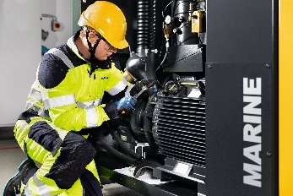

If required, a Service Technician can be with the ship for service purposes at your next port of call.

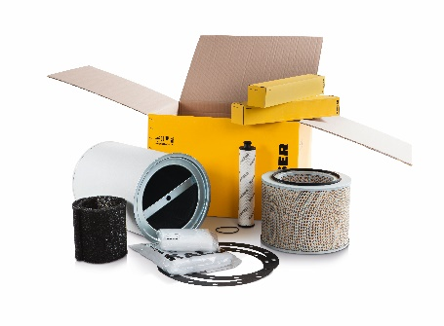

Special service kits for marine compressors make servicing a simple task.

