Kaeser Kompressoren at SMM 2022
Compressed air ahoy!
Dependable, energy-saving operation, coupled with highly reliable service, makes rotary screw compressors and blowers from Kaeser Kompressoren a perfect match for applications aboard ocean-going vessels. Highly efficient solutions are available, whatever your requirements.
No matter whether it’s service air or compressed air for special applications such as nitrogen generation, Kaeser offers the perfect solution for all shipboard compressors. Reliability is a key feature of Kaeser’s marine compressors, which are certified by all the principal marine industry authorities (American Bureau of Shipping, Bureau Veritas, Det Norske Veritas, RINA, Lloyds’s Register, Korean Register, etc.). In addition to the reliability of its equipment, Kaeser also offers a Marine Service which ensures help is always available should any issues arise, as well as for regular service intervals, no matter where in the world you may be.
The use of dual-fuel (DF) propulsion systems offers modern vessel operators decisive advantages when it comes to achieving a progressive and leading market position. As a future-oriented owner, why not double your lead by installing the most energy-efficient and cost-effective nitrogen system available on board your ship? With its SK/ASK/ASD-series rotary screw marine compressors, Kaeser can provide the perfect solution. Flow rates range between 1.3 and 5.4 m³/min and stable discharge pressures from 8 to 16 bar(g).
Kaeser Kompressoren also offers specially adapted blowers in its marine product range, which can be used to supply air for such applications as air lubrication systems, or wastewater treatment systems aboard cruise ships. Blowers are also used in anti-heeling systems, which serve to preserve cargo during loading and unloading.
You will find Kaeser at: Hall A3 / Stand 114

Approved for publication, copy appreciated

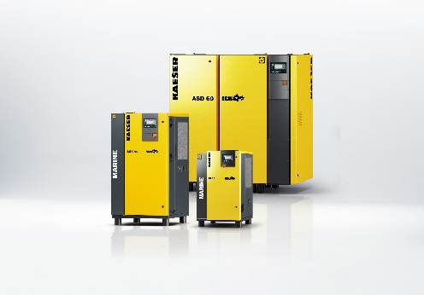

Kaeser Marine provides the most effective solution for all requirements.

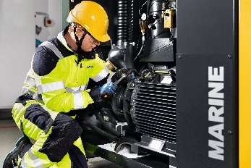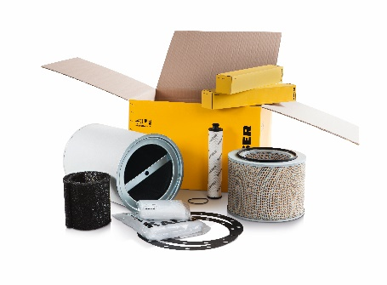

If required, a Service Technician can be with the ship for service purposes at your next port of call. Special service kits for marine compressors make servicing a simple task.

